Class works:

Task 1 : Design of IIR filters

Code:

clc;

clear all;

close all;

FN=1000/2;

fc=300; %cut off freq

N=5; %filter order

[z,p,k]=buttap(N); %creating analog filter

w=linspace(0,FN/fc,1000);

h=freqs(k\*poly(z),poly(p),w);

f=fc\*w;

plot(f,20\*log10(abs(h))),grid

ylabel('Magnitude(dB)')

xlabel('frequency(Hz)')

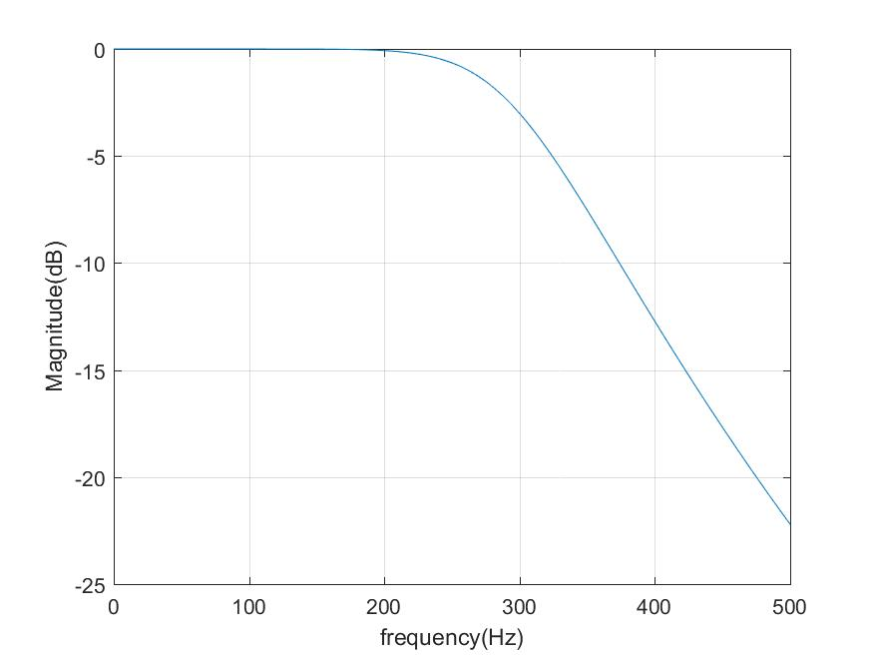

Figure 6.1 : IIR filter design

Task 2: Design of IIR filters by impulse invariant method.

Code:

Fs=1000; %sampling freq

fc=300; %cutoff freq

WC=2\*pi\*fc; %cutoff freq in radian

N=5;

[b,a]=butter(N,WC,'s'); %creating analog filter

[z,p,k]=butter(N,WC,'s');

[bz,az]=impinvar(b,a,Fs); %determine coeffs of IIR filter

[h,f]=freqz(bz,az,512,Fs); %512 points are taken,can be changed

plot(f,20\*log10(abs(h))),grid

ylabel('Magnitude(dB)')

xlabel('frequency(Hz)')

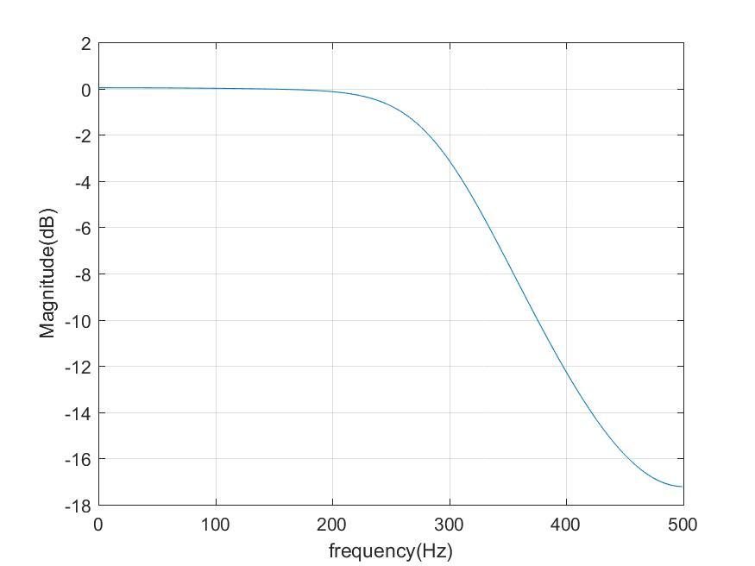

Figure 6.2 : Design of IIR filters by impulse invariant method

Task 3: Design of IIR filters by impulse invariant method.

Code:

N=2; %filter order

Fs=1280; %sampling freq

fc=150; %cutoff freq

WC=2\*pi\*fc; %cutoff freq in radian

[b,a]=butter(N,WC,'s'); %creating analog filter

[z,p,k]=butter(N,WC,'s');

[bz,az]=impinvar(b,a,Fs); %determine coeffs of IIR filter

subplot(2,1,1) %plot magnitude freq. response

[H,f]=freqz(bz,az,512,Fs); %512 points are taken,can be changed

plot(f,20\*log10(abs(H)))

ylabel('Magnitude Response(dB)')

xlabel('frequency(Hz)')

subplot(2,1,2) %plot pole zero diagram

zplane(bz,az)

zz=roots(bz) %poles and zeros

pz=roots(az) %poles in z plane

Output:

zz = 0

pz =

0.5154 + 0.2955i

0.5154 - 0.2955i

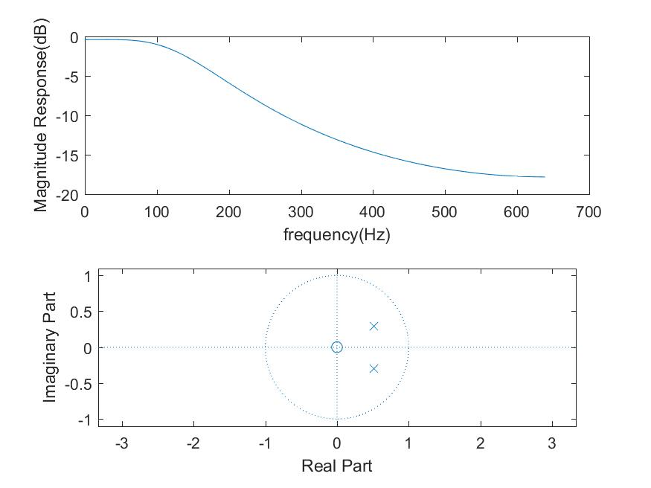

Figure 6.3 : Design of IIR filters by impulse invariant method

Task 4:Design of IIR filters by filter,overlap,impulse invariant, bilinear method

clc;

clear all;

close all;

fs = 1e4;

t = 0:1/fs:5;

sw = sin(2\*pi\*262.62\*t);

n = 0.1 \* randn(size(sw));

swn = sw + n;

%butterworth filter of order 2 with a cutoff at 400H

N = 2;

FN = fs/2;

fc = 150;

FC = fc/FN;

[b, a] = butter(2, 400/(fs/2));

figure(1);

w = linspace(0, FN/fc, 400);

[h, f] = freqz(b, a);

plot(f, 20\*log10(abs(h)));

grid;

ylabel('Magnitude (dB)');

xlabel('Frequency (Hz)');

%filter with filter

y1 = filter(b,a,swn);

figure(2);

subplot(311);

plot(t,sw), axis([0 0.04 -1.1 1.1]), title('Original Signal');

soundsc(sw,1e4)

subplot(312);

plot(t,swn), axis([0 0.04 -1.1 1.1]), title('Noisy Signal');

soundsc(swn,1e4)

subplot(313);

plot(t,y1), axis([0 0.04 -1.1 1.1]), title('Using Filter');

soundsc(y1,1e4)

%zero-phase filter

y2 = filtfilt(b,a,swn);

figure(3);

subplot(311);

plot(t,sw), axis([0 0.04 -1.1 1.1]), title('Original Signal');

soundsc(sw,1e4)

subplot(312);

plot(t,swn), axis([0 0.04 -1.1 1.1]), title('Noisy Signal');

soundsc(swn,1e4)

subplot(313);

plot(t,y2), axis([0 0.04 -1.1 1.1]), title('Using Filtfilt(zero-phase filter)');

soundsc(y2,1e4)

%impulse invariant method

[bz1, az1] = impinvar(b, a, fs);

y3 = filter(bz1,az1,swn);

figure(4);

subplot(311);

plot(t,sw), axis([0 0.04 -1.1 1.1]), title('Original Signal');

soundsc(sw,1e4)

subplot(312);

plot(t,swn), axis([0 0.04 -1.1 1.1]), title('Noisy Signal');

soundsc(swn,1e4)

subplot(313);

plot(t,y3), axis([0 0.04 -1.1 1.1]), title('Using Filter(Impulse Invariant)');

soundsc(y3,1e4)

%bilinear transfer method

[bz2, az2] = bilinear(b, a, fs);

y4 = filter(bz2,az2,swn);

figure(5);

subplot(311);

plot(t,sw), axis([0 0.04 -1.1 1.1]), title('Original Signal');

soundsc(sw,1e4)

subplot(312);

plot(t,swn), axis([0 0.04 -1.1 1.1]), title('Noisy Signal');

soundsc(swn,1e4)

subplot(313);

plot(t,y4), axis([0 0.04 -1.1 1.1]), title('Using Filter(Bilinear)');

soundsc(y4,1e4)

%% overlap add method method

y5 = fftfilt(b,swn);

figure(6);

subplot(311);

plot(t,sw), axis([0 0.04 -1.1 1.1]), title('Original Signal');

%%

%%

soundsc(sw,1e4)

subplot(312);

plot(t,swn), axis([0 0.04 -1.1 1.1]), title('Noisy Signal');

soundsc(swn,1e4)

subplot(313);

plot(t,y5), axis([0 0.04 -1.1 1.1]), title('Using Filter(Overlap Add)');

soundsc(y5,1e4)

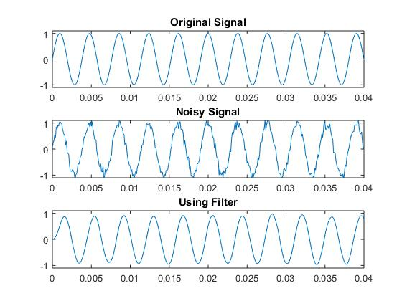

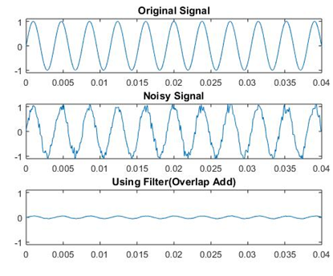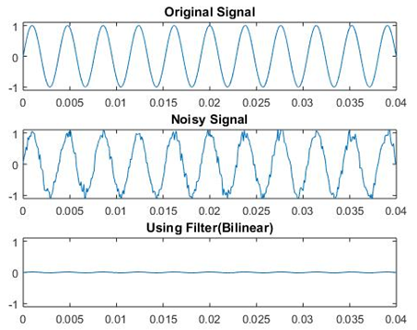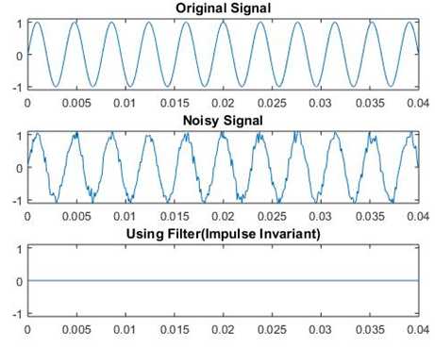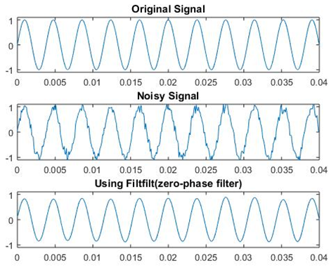

Figure 6.10 : Output comparison for different filters

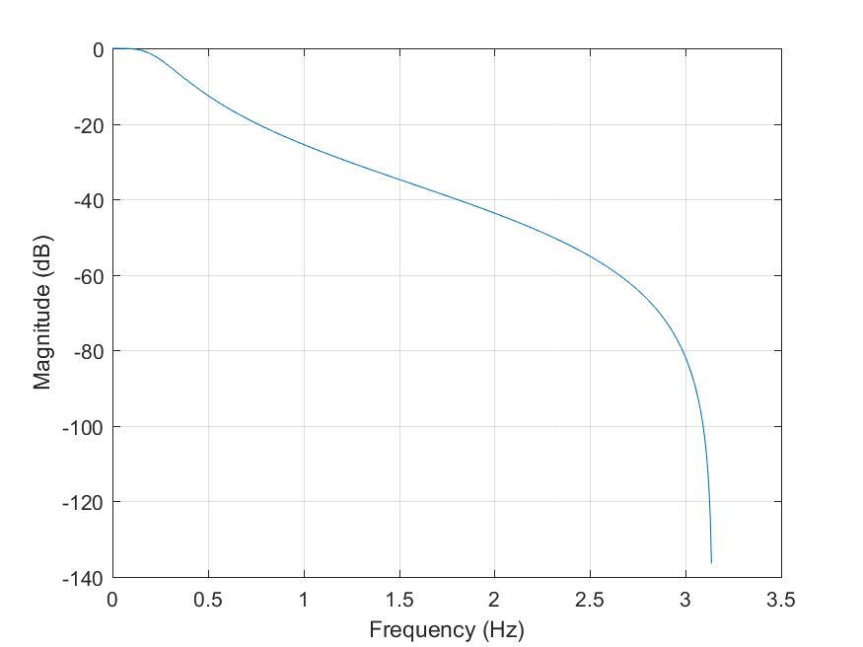 butterworth filter of order 2 with a cutoff at 400H

Figure 6.5: filter with filter

Figure 6.4: butterworth filter of order 2 with a cutoff at 400H

N = 2;

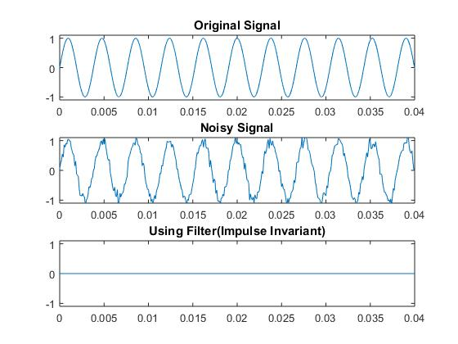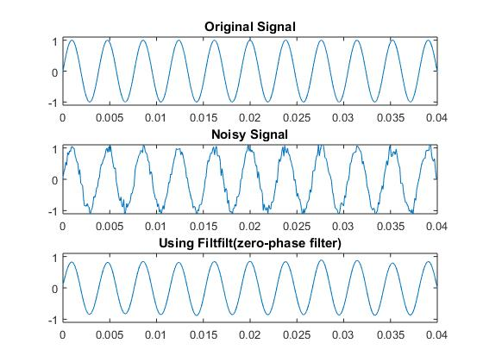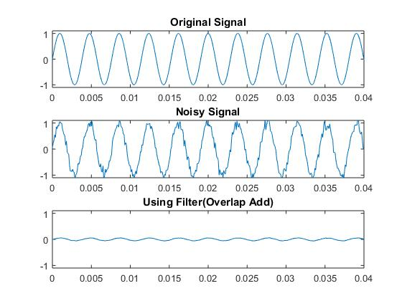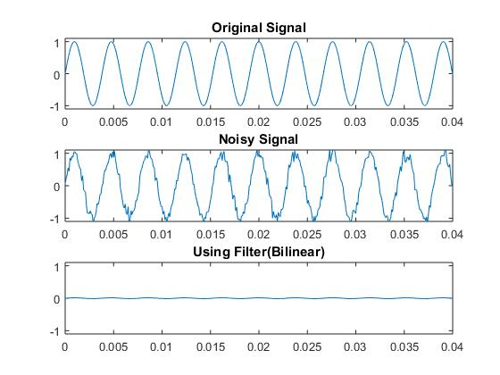

Figure 6.6: zero-phase filter

Figure 6.7:filter with impulse invariant method

Figure 6.8:filter with bilinear transfer method

Figure 6.9: overlap add method method